- Conjuguez le verbe (to visit) à la 3° pers. du singulier au… (9 pts)
Temps | Présent Simple | Présent Progressif
Forme affirmative | He visits | He is visiting
Forme interrogative | Does he visit ? | Is he visiting?
Forme négative | He doesn’t visit | He isn’t visiting
 | Futur Simple
Forme affirmative | He will visit | He will be visiting
Forme interrogative | Will he visit ? | Will he be visiting?
Forme négative | He will not (won’t) visit | He won’t be visiting
 | Prétérit Simple
Forme affirmative | He visited | He was visiting
Forme interrogative | Did he visit ? | Was he visiting?
Forme négative | He did not visit | He wasn’t visiting

2. Regardez le journal intime de Walter. Aujourd’hui nous sommes jeudi. Dites ce qu’il a fait, ce qu’il fait et ce qu’il fera, n’oubliez pas d’employer des repères temporels. 5 pts

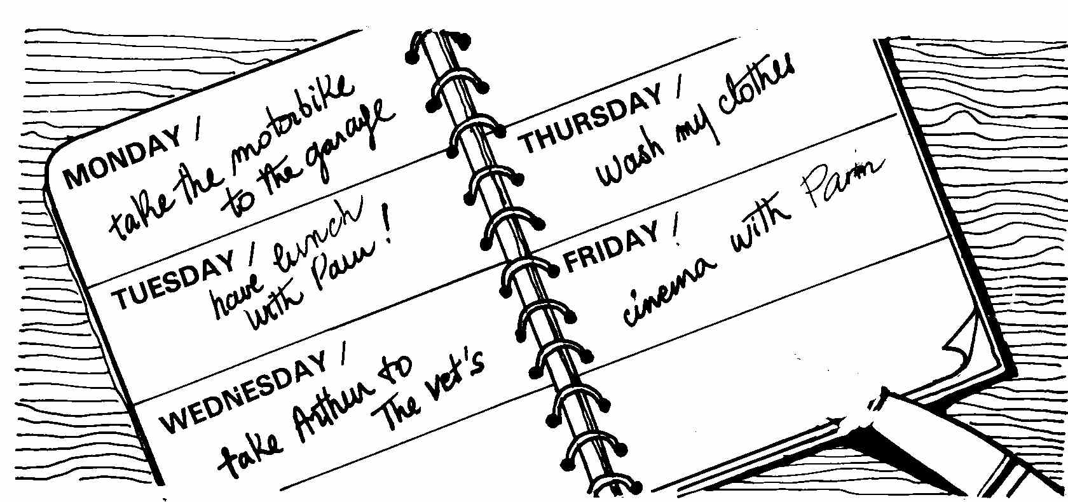
Today Walter is washing his clothes. Yesterday he took Arthur to the vet’s and the day before yesterday he had lunch with Pam. On Monday he took the motorbike to the garage. Tomorrow he will go the cinema with Pam.
3. Mason fait visiter Washington à Suzy qui s’extasie. Complète ce que dit Mason en utilisant un superlatif à chaque fois. 4 pts
a. Suzy : Wow ! This monument is so impressive !
Mason: Yeah, well it’s the Lincoln Memorial . I think it’s the most impressive
monument in Washington.
b. Suzy : That’s incredible, this avenue is so large!
Mason: I know. It’s The Mall, it’s the largest avenue in Washington D.C.
c. Suzy : Amazing! This house looks so old!
Mason: Well, it’s The Old Stone House, it’s the oldest house in D.C.
d. Suzy : I’m excited to visit The White House, I think it is so beautiful!
Mason: You’re right, it’s the most beautiful building in Washington D.C.
4. Mason a vraiment beaucoup de mal à contacter Suzy pour lui demander de venir avec eux à Washington D.C. Rappelez-vous ce qu’il dit à Jerry. Conjuguez les verbes, n’oubliez pas le verbe de la proposition principale est au futur! 3 pts
Phone call 1
”I will call (call) her tonight when I am at home.”
Phone call 2
”I will ask (ask) her tomorrow when I see(see) her then.”
Phone call 3
” If I am (be) home early I will send(send) her an email.”
5. During winter break Jerry is going to visit Washington D.C with his friend Mason. Mason would like Jerry’s cousin, Suzy, to come with them. 14 pts
a. Why? (1 pt)
Because / he has a feeling for her / (or) he has a crush on her (or) / he fell in love with her.
b. Jerry tells him to ask her. Did Mason do it? Explain and justify. (3 pts)
No, he didn’t have the courage to ask her. He didn’ call her, he didn’t ask her in gym because she was with a bunch of friends and finally he didn’t send her an email. I think he is too shy.
c. What does Jerry think of him? What does he finally do? (2 pts)
Jerry thinks Mason is hopeless. Finally he will call and ask his cousin.
d. Does Suzy accept to join them? What is her reaction? What does she think of Mason? (3 pts)
Yes, she does. She is terribly happy and excited. She has a crush on Mason too; she thinks he is so funny and the cutest guy ever.
e. What does she promise her friend? (2 pts)
She promises her friend whe will tell her everything when she comes home and she will send her loads of photos.
f. Imagine Mason and Suzy’s day Washington D.C. (3 pts)
They will be so happy to be together that Mason will sit next to her when they are in the Red Line. Maybe he will hold her hand when they visit the White House and on their way home maybe he will try to kiss her.

Voilà il suffisait d’apprendre les phrases du cahier. Certains d’entre vous ne se rappelaient même pas de l’histoire GRRRR



