Name : ………………………………………………………………………. Class :
Date : ………………………………………………………………………..
……………………………………………………………………… Mark : / 30

English Test

I. Complète le tableau : 4 pts
Base verbale | prétérit | Participe passé | français
Go | went | gone | aller
buy | bought | bought | Acheter
see | I saw | seen | voir
take | took | Taken | prendre
Forget | forgot | forgotten | oublier
feed | fed | fed | Nourrir (animaux)
Put | put | put
bite | I bit | bitten | mordre

II. Tu es en séjour long dans une école en Australie et tu participes à l’organisation d’une excursion avec le club « Découverte » . Tes amis et toi avaient une liste de choses à faire :
a. Hi, Daniel, have you checked the prices for the cruise?
No, I haven’t. / No, not yet.
And you /what about you Darren and Vicky? Have you filled in the reservation forms?
Yes, we have. / Yes, no problem.
Great! Have you called the hotel to reserve the rooms?
No, not yet / No, I haven’t.
You are a great help, you must hurry; I have already made the list of the participants.

b. Maintenant , rédige un mot au professeur responsable pour lui dire où en sont les préparatifs. 4 pts
For Mrs Lewis :
I have made the list of the participants. Daniel hasn’t checked the prices for the cruises yet. Daren and Vicky have filled in the reservation forms but they haven’t called the hotel to reserve the rooms yet.

III.. Conjugue le verbe entre parenthèse soit au prétérit soit au present perfect .
Attention n’oubliez pas l’ordre des mots ! 5 pts
a. Look ! They haven’t cleaned their shoes yet.
b. I cleaned mine yesterday.
- Have you ever been to New York?
- Last year she did not visit her grandparents.
- He has already put away the dishes.

IV. Tu es un ranger et tu arrives sur un campement. Tu n’es pas content, que dis-tu au responsable du groupe? 6 pts
N’oublie pas de constater, de lui rappeler les règles du camping, de justifier tes remarques (ce qui arrivera peut – être, de ce qui est possible qui se réalise), d’exprimer ton mécontentement.
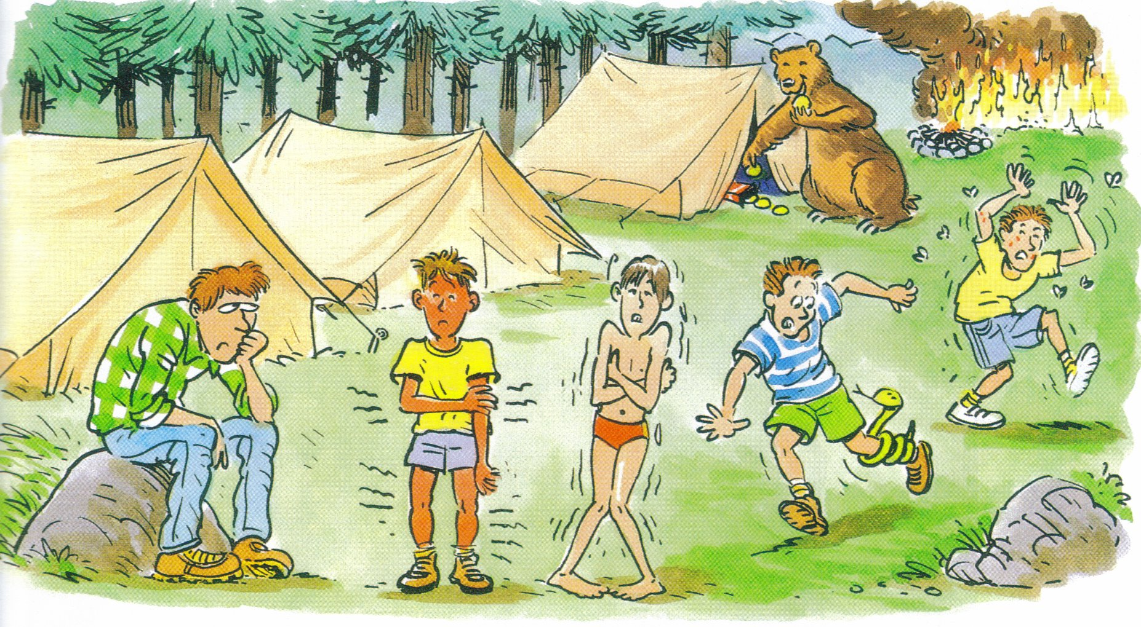

Look you have built a fire!You shouldn’t do that, do you realize, it is dangerous because dead leaves may catch fire and we could have a bush fire in no time!
You shouldn’t leave food waste or food around the tent because wild animals may come by and ead eat it. You should store food away and clean the plates. Human food could make them sick.
You shouldn’t approach wild life it can be dangerous, (attention deux formulations sont possible) you may get bitten or injured or wild animals can bite you. Yould always have a first aid kit with you.

V. Traduis : 7 pts
1.Mrs Kramer est fâché car Mr. Kramer lui a piqué son portable. 1,5
Mrs Kramer is cross because Mr Kramer has pinched her her mobile phone.
2. Il est dangereux de caresser un animal sauvage car vous pouvez vous faire griffer. 2
It is dangerous to stroke wild animals because you may get scratched.
3. Je n’y crois pas !Vous venez de manger et il y a encore de la nourriture sur les assiettes . 1.5
I don’t believe it ! You have just eaten and there is still some food on the plates.
4. Ne recommencez jamais. 0.5
Never do that again.
5. Vous avez cueilli un gros bouquet de fleurs ! Vous vous imaginez si tout le monde cueillait des fleurs ? 1.5
You have picked up a big bunch of flowers ! Do you realize if everybody picked up flowers?

