Expression écrite
4. Regarde bien le dessin et écris autant de phrases que tu veux. /10
Emploie bien sûr le vocabulaire, structures grammaticales nouvellement apprises. Il est évident que tu ne dois pas employer la même phrase 10 fois de suite. Les phrases peuvent être affirmatives, interrogatives et négatives. Vous pouvez décrire, rédiger un dialogue…….
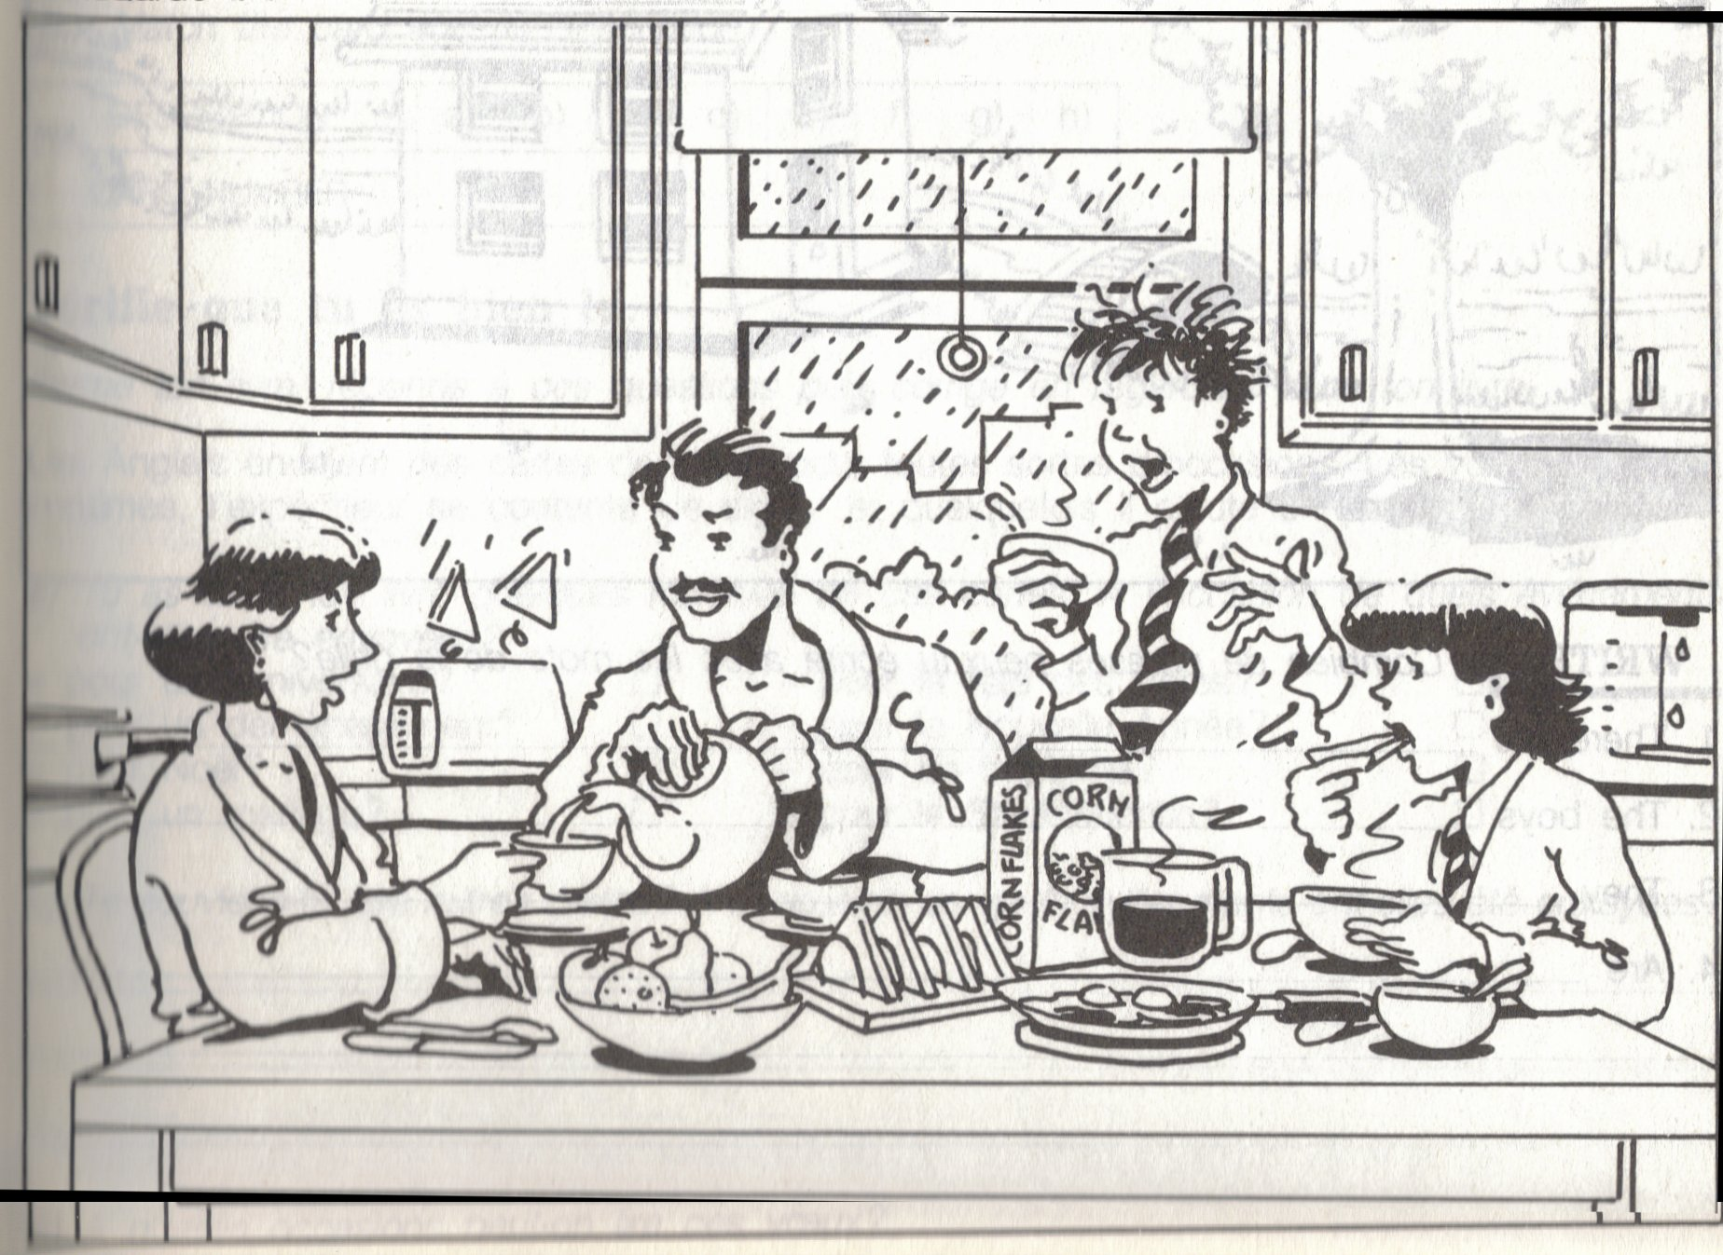

Regardez attentivement le temps employé ainsi que la forme (be+ing= now / simple= habitude)
The scene takes place in the morning in the kitchen. It is not a week-end as the children are wearing a uniform. It is raining outside.
The Smiths are having breakfast. On the table there are some toasts, fruit, bacon and eggs, cereal, tea and coffee. Toasts are jumping out the toaster. Mr Smith is pouring some tea to his wife:
- “Would you like some tea, my dear?
- Yes, please.”
Mr and Mrs Smith are still wearing their dressing gowns (or they are not dressed). Suzan is having coffee and eating a toast. She is ready to go to school. Brian is having some cereal and standing. He woke up late, he always gets up late in the morning. He is going to be late for school. He didn’t have time to brush his hair.

5. Dis –le en anglais /15
1. Ecris deux phrases sur Marilyn Monroe (1926-1962) écris les dates en lettres 2
Marilyn Monroe was a famous actress, she was born in nineteen twenty-six and she died in nineteen sixty-two.
2. Dis qui était Dickens et ce qu’il a fait. 2
Dickens was a writer, he wrote a lot of novels : Oliver Twist, David Copperfield etc…
3. Demande si Mr Mac Guire travaille dans une boutique. 1.5
Does Mr Mac Guire work in a shop ?
4. Dis qu’il est souvent debout. 1
He stands a lot or he often stands.
5. Dis ce que tu aimes faire comme passe-temps. 1
I love reading, going to the cinema, chatting with my friends…
6. Dis que tu ne patines jamais mais que tu nages souvent. 1.5
I never skate but I often swim.
7. Demande à un camarade comment il est allé à Londres l’an dernier. 1.5
How did you go to London last year ?
8. Demande-lui avec qui il y est allé. 1.5
Who did you go with ?
9. Demande-lui s’il a mangé des œufs au bacon hier. 1.5
Did you have any bacon and eggs yesterday ?
10. Demande à ta mère si il y a des champignons dans la salade. 1.5
Are there any mushrooms in the salad ?

